Design thinking for software engineering

Situation 5: Job portals provide little feedback to rejected candidates

Lab 1 Report:

Observations
- Many candidates frequently experience rejection without receiving any specific feedback during the job application process.
- Candidates often wait for extended periods before receiving a rejection or no response at all.
- The absence of feedback leads to frustration and uncertainty among candidates regarding their performance.
- Without clear feedback, candidates struggle to identify areas for improvement.
- Companies do not provide proper feedback because they think it as time and resource consuming process.
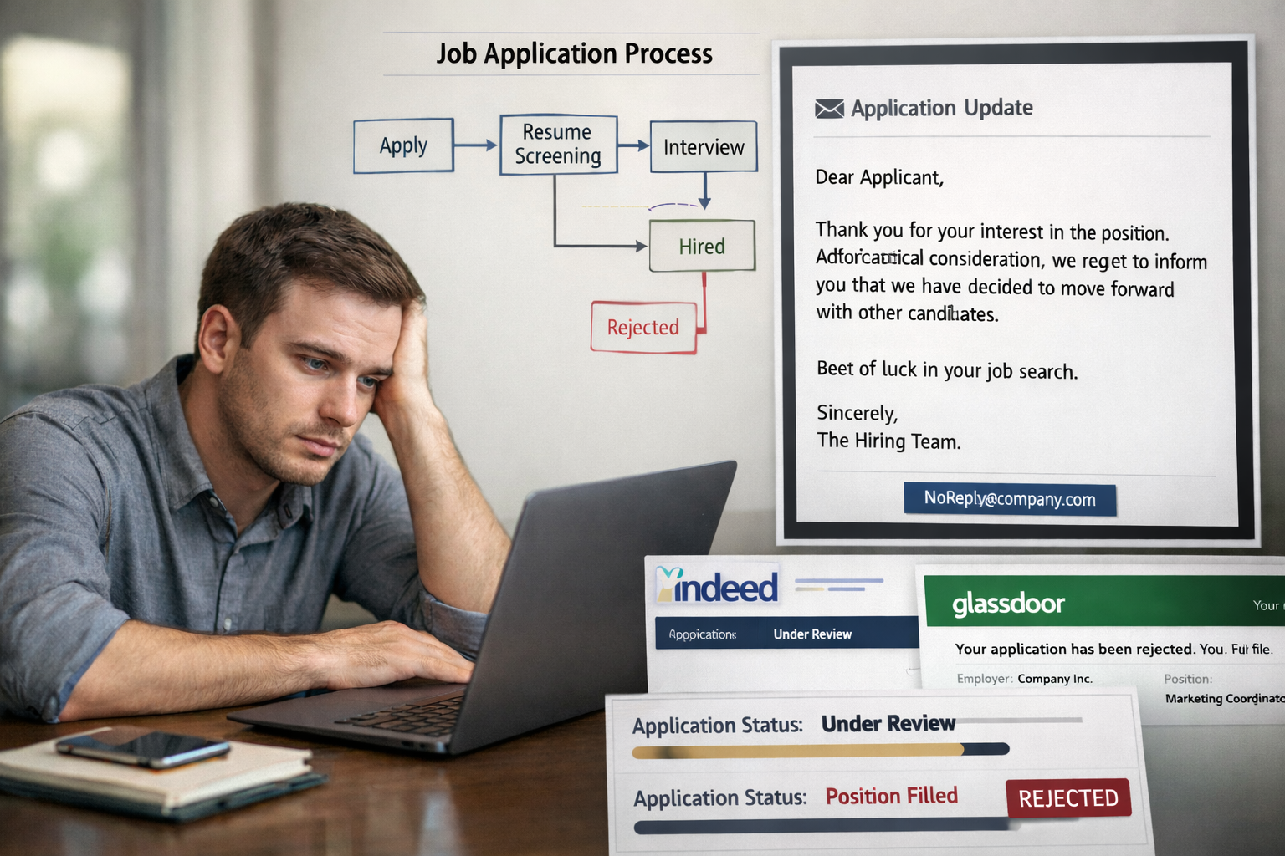

Stakeholder Identifications:
- Most affected candidates are especially freshers and early-career candidates are the most affected as they depend heavily on feedback to understand what skills or qualification they lack.
- Job seekers are the primary stakeholders because they invest their time, efforts and emotional energy and receive nothing when get rejected.
- Websites like job portals that manage applications. They design the system and don’t push feedback because it doesn’t benefit their business much.
- Companies and HR people who hire. They reject many candidates and usually don’t give feedback to save time and avoid problems.
- Many experienced professionals also face these repeated rejections without knowing if the issue is salary, skills or role mismatch.

Interview questionnaire & responses
- Which job portals do you mostly use?
- How often do you apply for jobs through online portals?
- On average, how many jobs have you applied for online?
- After applying for jobs, do you usually receive feedback?
- What kind of response do you usually receive?
- How long do job portals usually take to respond?
- Do you feel lack of feedback affects your job search negatively?
- What problems does lack of feedback cause you?
- Have you ever stopped applying on a job portal due to no feedback?
- Do you think job portals should provide proper feedback to rejected candidates?
- What type of feedback would be most helpful?
- Any suggestions to improve the feedback system in job portals?
Key Insights:
- Young job seekers (22–25 years) are the most affected by lack of feedback, as they actively apply and rely heavily on online job portals.
- LinkedIn, Naukri, and Indeed are the most frequently used job portals, making them the main platforms shaping the candidate experience.
- Feedback is inconsistent and unreliable — only a minority receive feedback regularly, while many get it sometimes, rarely, or never.
- Most responses lack quality and clarity, as candidates usually receive only status updates (selected/rejected), automated replies, or no response, without meaningful explanations.
- Lack of proper feedback causes serious negative effects, including inability to identify skill gaps, repeated mistakes, reduced confidence, demotivation, and wasted effort.
- Users strongly demand structured, transparent, and interactive feedback systems, including:
- Detailed rejection reasons
- Skill-gap and performance-based feedback
- Clear application status tracking
- Faster responses
- Interactive communication from portals
- Structured feedback templates after interviews
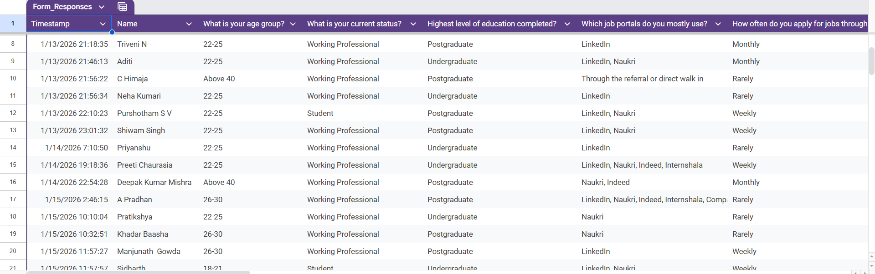
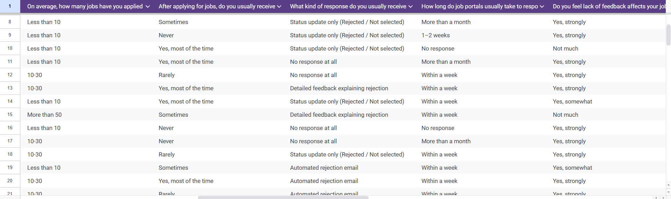
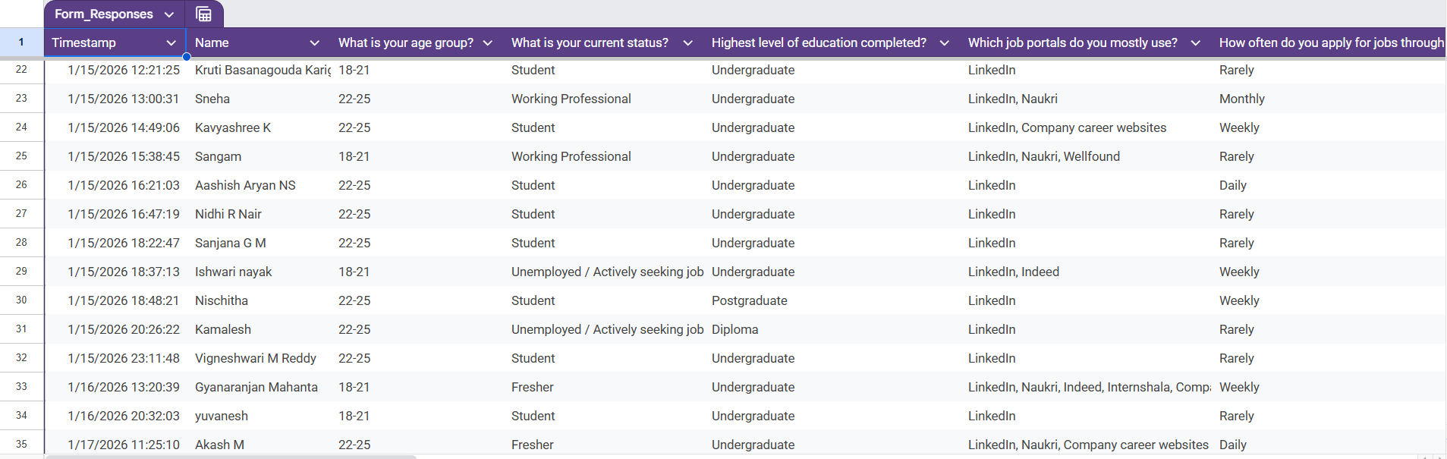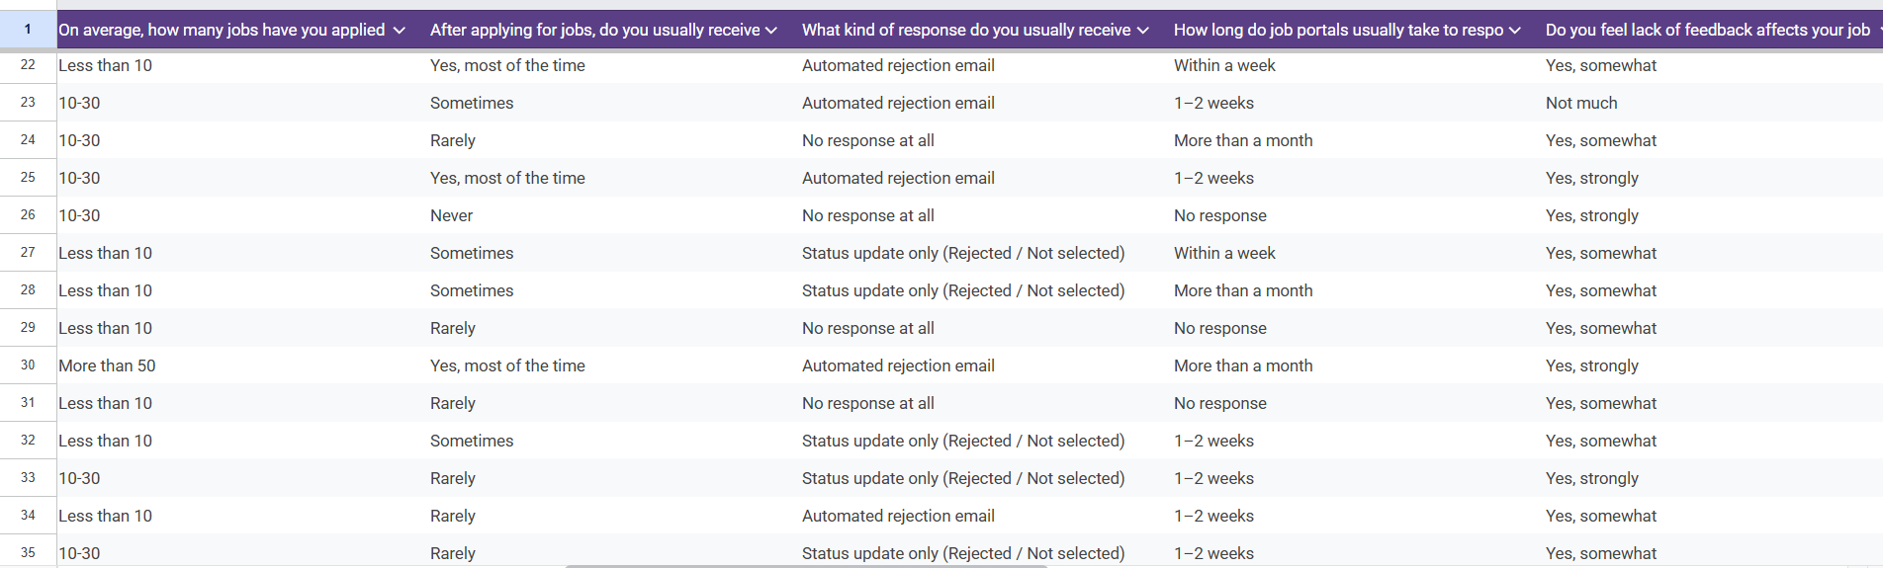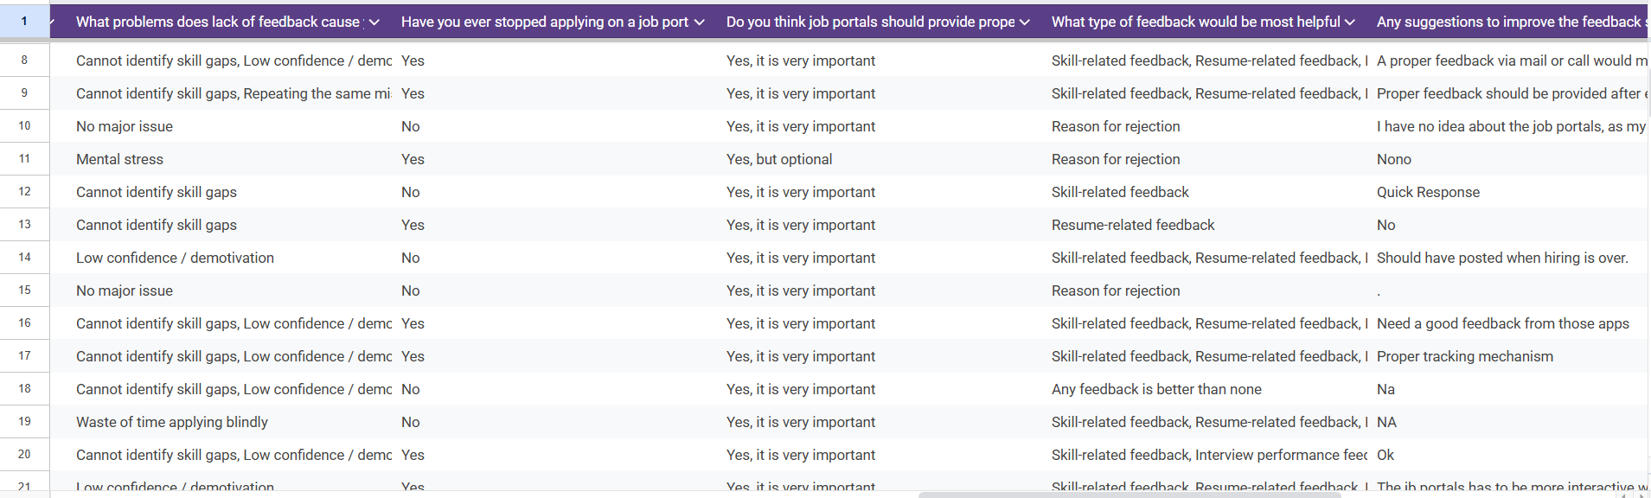
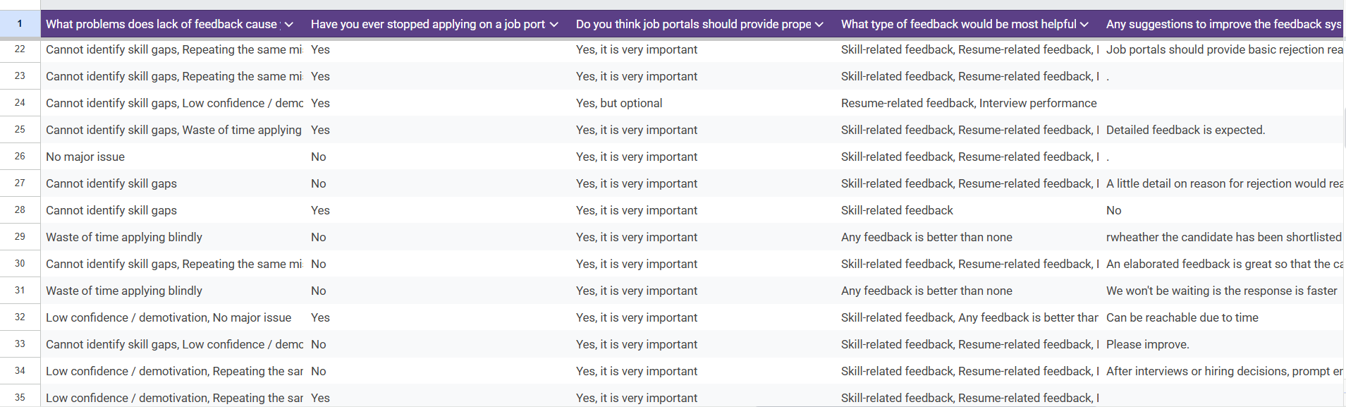

Pain-Point Analysis
Category | Pain Points Identified from Survey
Functional Pain Points | • Inconsistent or missing feedback after job applications.  • Poor quality feedback limited to status updates or automated emails.  • Delayed responses or no response, creating uncertainty in application progress.
Emotional Pain Points | • Reduced confidence, demotivation, and mental stress due to lack of guidance.  • Frustration caused by repeated mistakes and inability to identify skill gaps.
Systemic Pain Points | • Lack of structured feedback mechanisms across job portals.  • Absence of transparent application tracking systems.  • Loss of trust leading to reduced engagement and abandonment of job portals.

While several pain points contribute to a poor job application experience, poor quality of feedback emerges as the most critical because it acts as the root cause that triggers emotional distress, repeated mistakes, and eventual disengagement from job portals.

Root Cause Identification
5-Why Analysis: Poor Quality of Feedback
Why 1: Why is the feedback poor in quality?
Because candidates mostly receive status updates, automated emails, or no explanation instead of detailed feedback.
Why 2: Why do portals provide only automated or minimal feedback?
Because feedback is not prioritized in the recruitment workflow and is treated as an optional step.
Why 3: Why is feedback not prioritized in the system?
Because job portals focus mainly on matching employers with candidates quickly, not on post-application learning or improvement.
Why 4: Why is learning and improvement not built into the platform design?
Because there is no structured feedback mechanism or standardized template integrated into the portal.
Why 5: Why is there no structured feedback mechanism?
Because providing detailed feedback is seen as time-consuming, non-mandatory, and offering little short-term business value to employers and portals.
Root cause is lack of a structured, mandatory feedback system integrated into job portal workflows.
Symptoms (What Users Experience)
- Status-only updates (selected/rejected)
- Automated rejection emails
- No clarity on reasons for rejection
- Inability to identify skill gaps
- Repeated application mistakes
- Loss of confidence and motivation
- Frustration and mental stress
- Users stop applying on job portals
Root Causes (Why the Problem Exists)
- No standardized feedback templates
- Feedback not enforced as a mandatory step
- Platform design prioritizes speed over learning
- Employers are not incentivized to give feedback
- Lack of transparency and tracking mechanisms
- Absence of candidate-centric system design

Wicked Problem Understanding
Problem: Rejected candidates using job portals do not receive feedback that helps them understand, learn, or improve after rejection.
Why the Problem Is Difficult to Define Clearly
- “Helpful feedback” means different things to different candidates (skills, resume, interview performance, or rejection reason).
- Feedback expectations vary by job role, experience level, and stage of the hiring process.
- Feedback is inconsistent across job portals (detailed, automated, delayed, or absent).
- Responsibility for providing feedback is unclear (job portal, recruiter, or employer).
Why the Problem Has Multiple Stakeholders with Conflicting Needs
- Candidates want detailed, timely, and actionable feedback.
- Employers prioritize fast hiring and minimal additional effort.
- Recruiters handle large volumes and rely on automation.
- Job portals focus on scalability and standardized workflows.
- These priorities conflict, limiting the depth and consistency of feedback.
Why the Problem Cannot Be Solved by a Single Solution
- Automation improves speed but reduces personalization.
- Manual feedback improves quality but is not scalable.
- Policy enforcement depends on employer participation.
- Feedback requirements differ across industries and roles.
The issue of rejected candidates not receiving feedback that enables learning and improvement qualifies as a wicked problem, as it is difficult to define uniformly, involves multiple stakeholders with conflicting needs, and cannot be resolved through a single technological or procedural solution.

Reflection
- It was correctly assumed that candidates often face rejection without meaningful feedback, leading to frustration and uncertainty.
- It was incorrectly assumed that the lack of feedback is always intentional; user responses showed it is often due to system limitations and automation.
- It was incorrectly assumed that faster responses alone would solve the issue; users revealed that feedback quality matters more than speed.
- Jumping to solutions early is risky, as focusing only on automation or response time can ignore deeper user needs such as clarity, learning, and personalization.
- Through this lab, I developed the ability to analyse problems from a user’s perspective by understanding real user experiences and emotions. I also learned how user insights help frame the problem accurately before designing solutions, rather than relying on assumptions.

